Portable Insulin Cooler

Creator: Joesphan Lu

Sponsor: Fred Josephson

2022

SYSTEM DESIGN

The goal of this project is to make an accessible, portable insulin cooler accessible to everybody. Insulin coolers on the market today are non-portable and/or very cost prohibitive. Most of them are passive, and not much more than a glorified thermos. The target users are mainly people with diabetes, who require insulin to be always accessible, of all financial statuses. This project should minimally be able to cool insulin for a long period of time, which will be highly dependent on the efficiency of the circuit design, as well as the insulative properties of the chassis. Additional features such as an app-based locating feature and datalogging will be made available. Through the app, the device will notify the user if the temperature ranges are exceeded.

BLOCK DIAGRAM

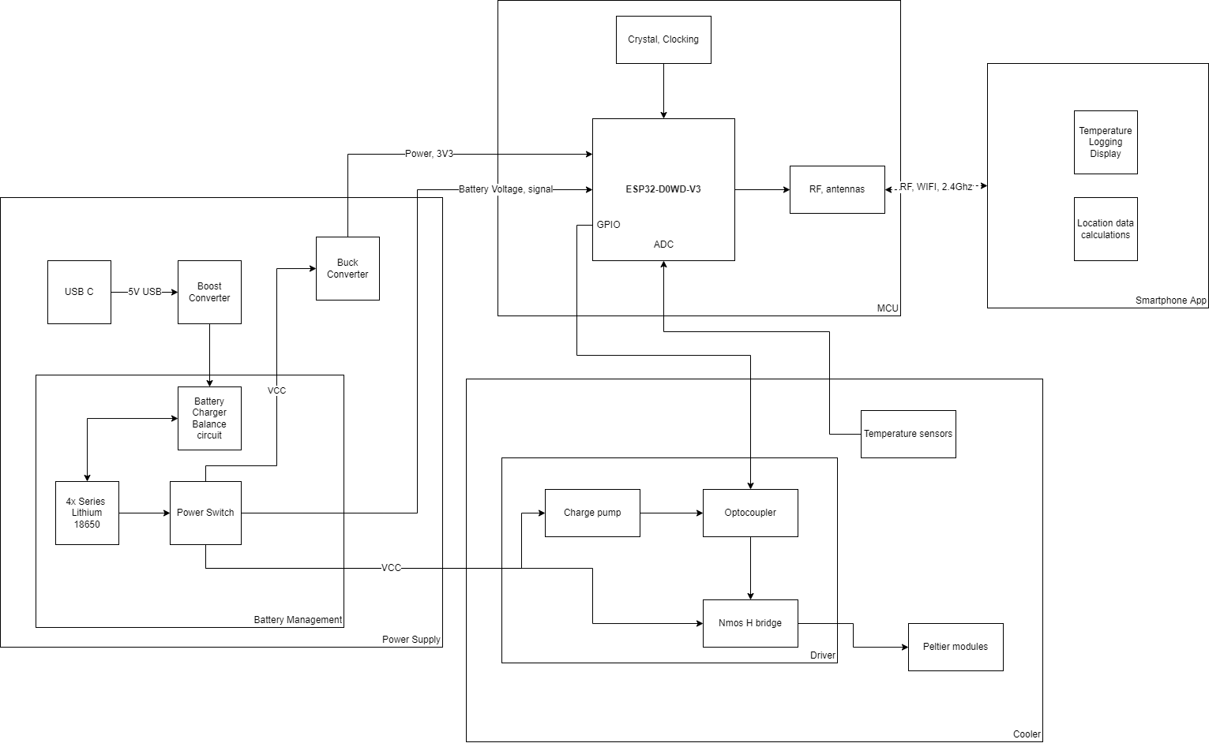

SCHEMATIC

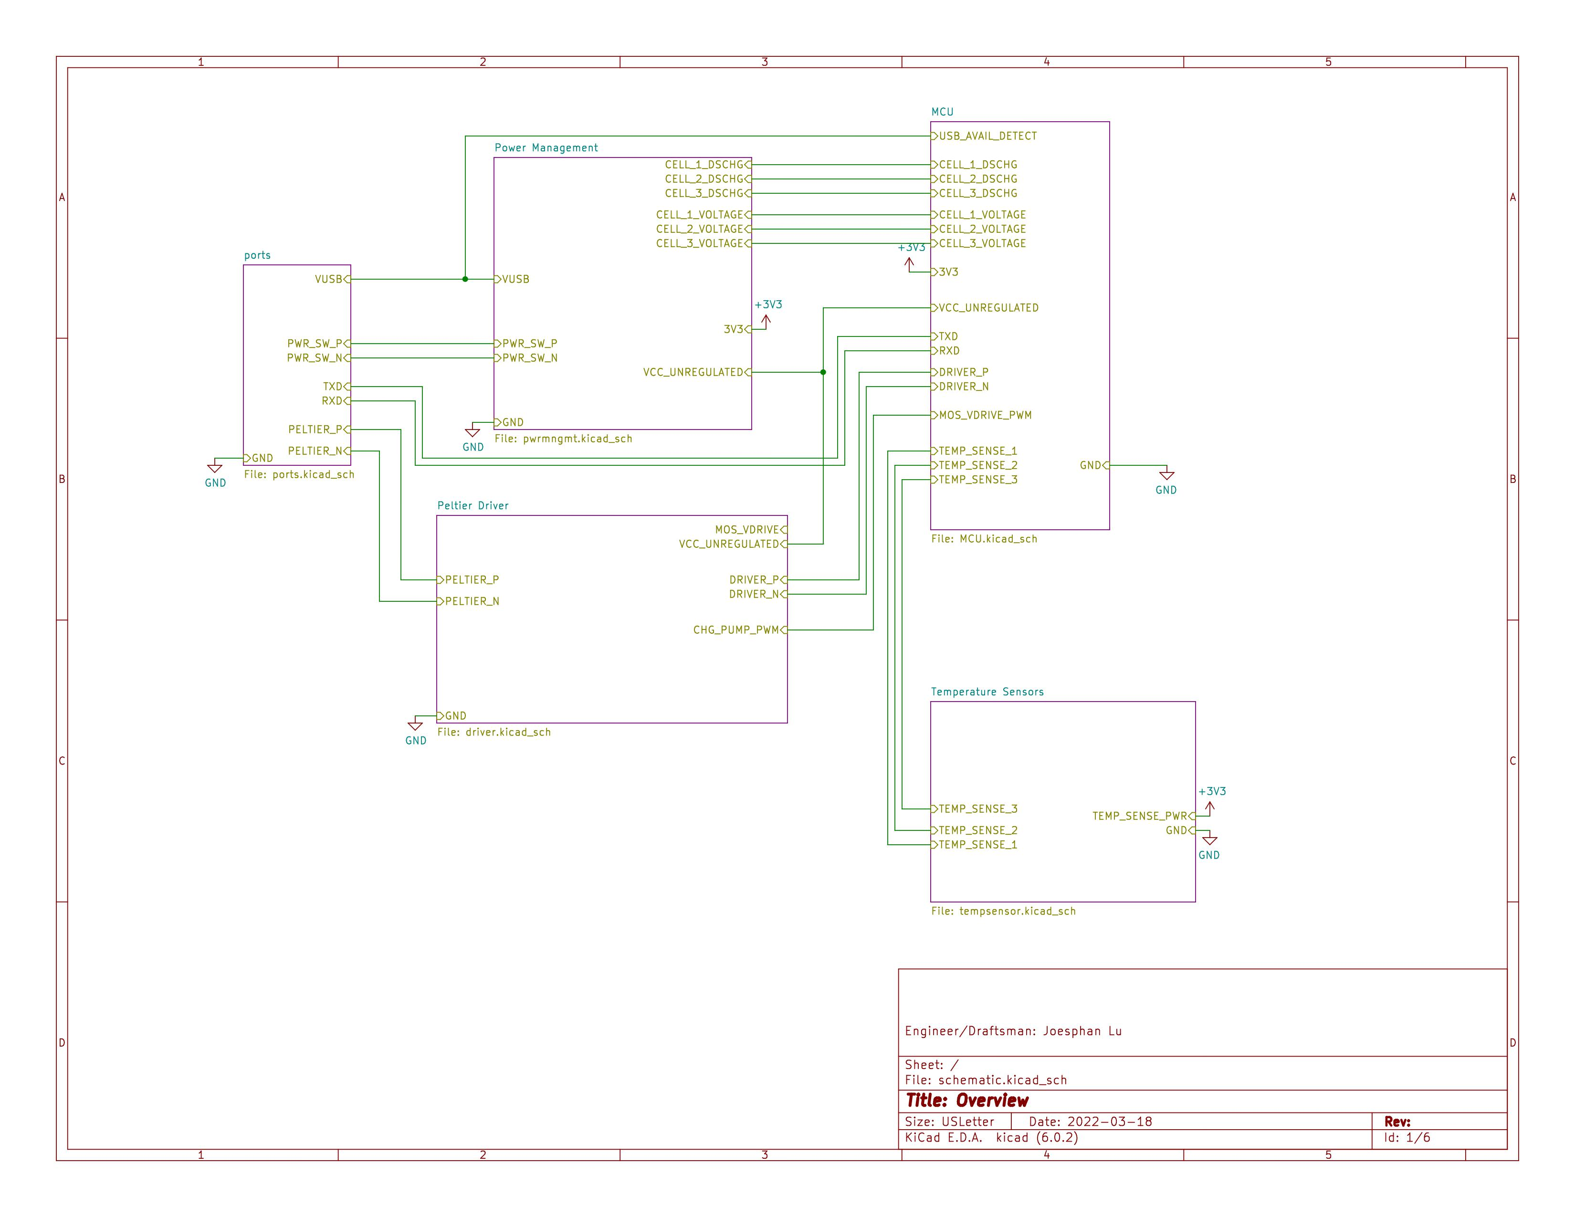

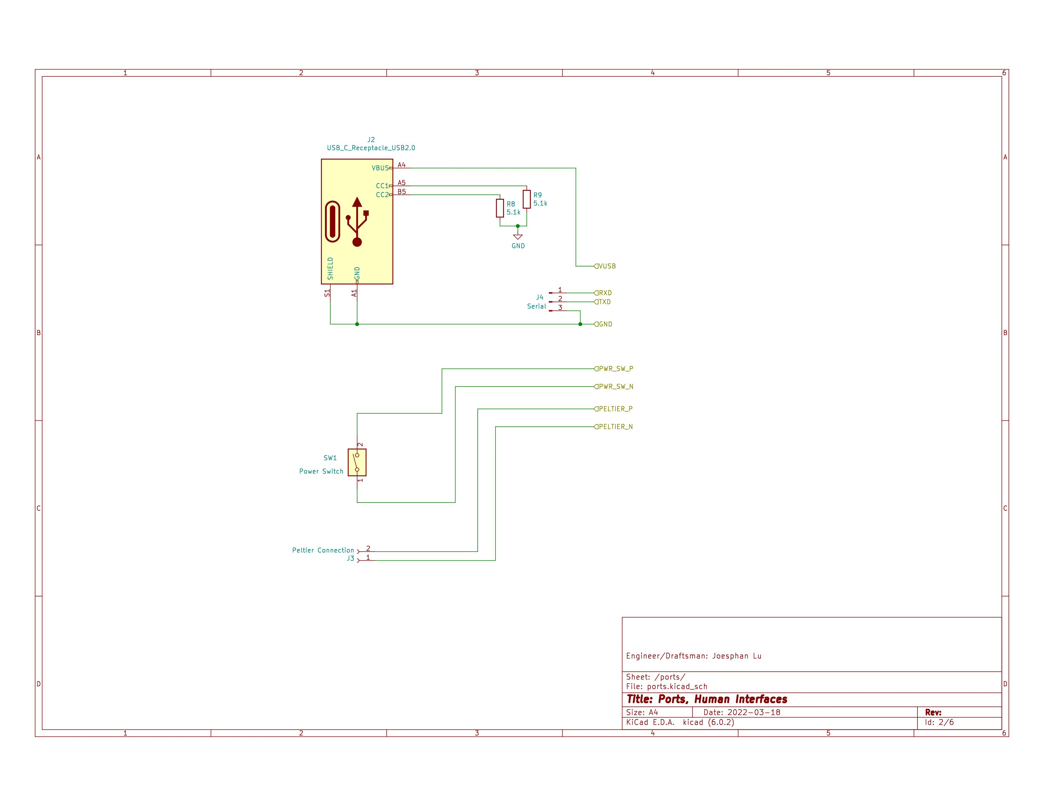

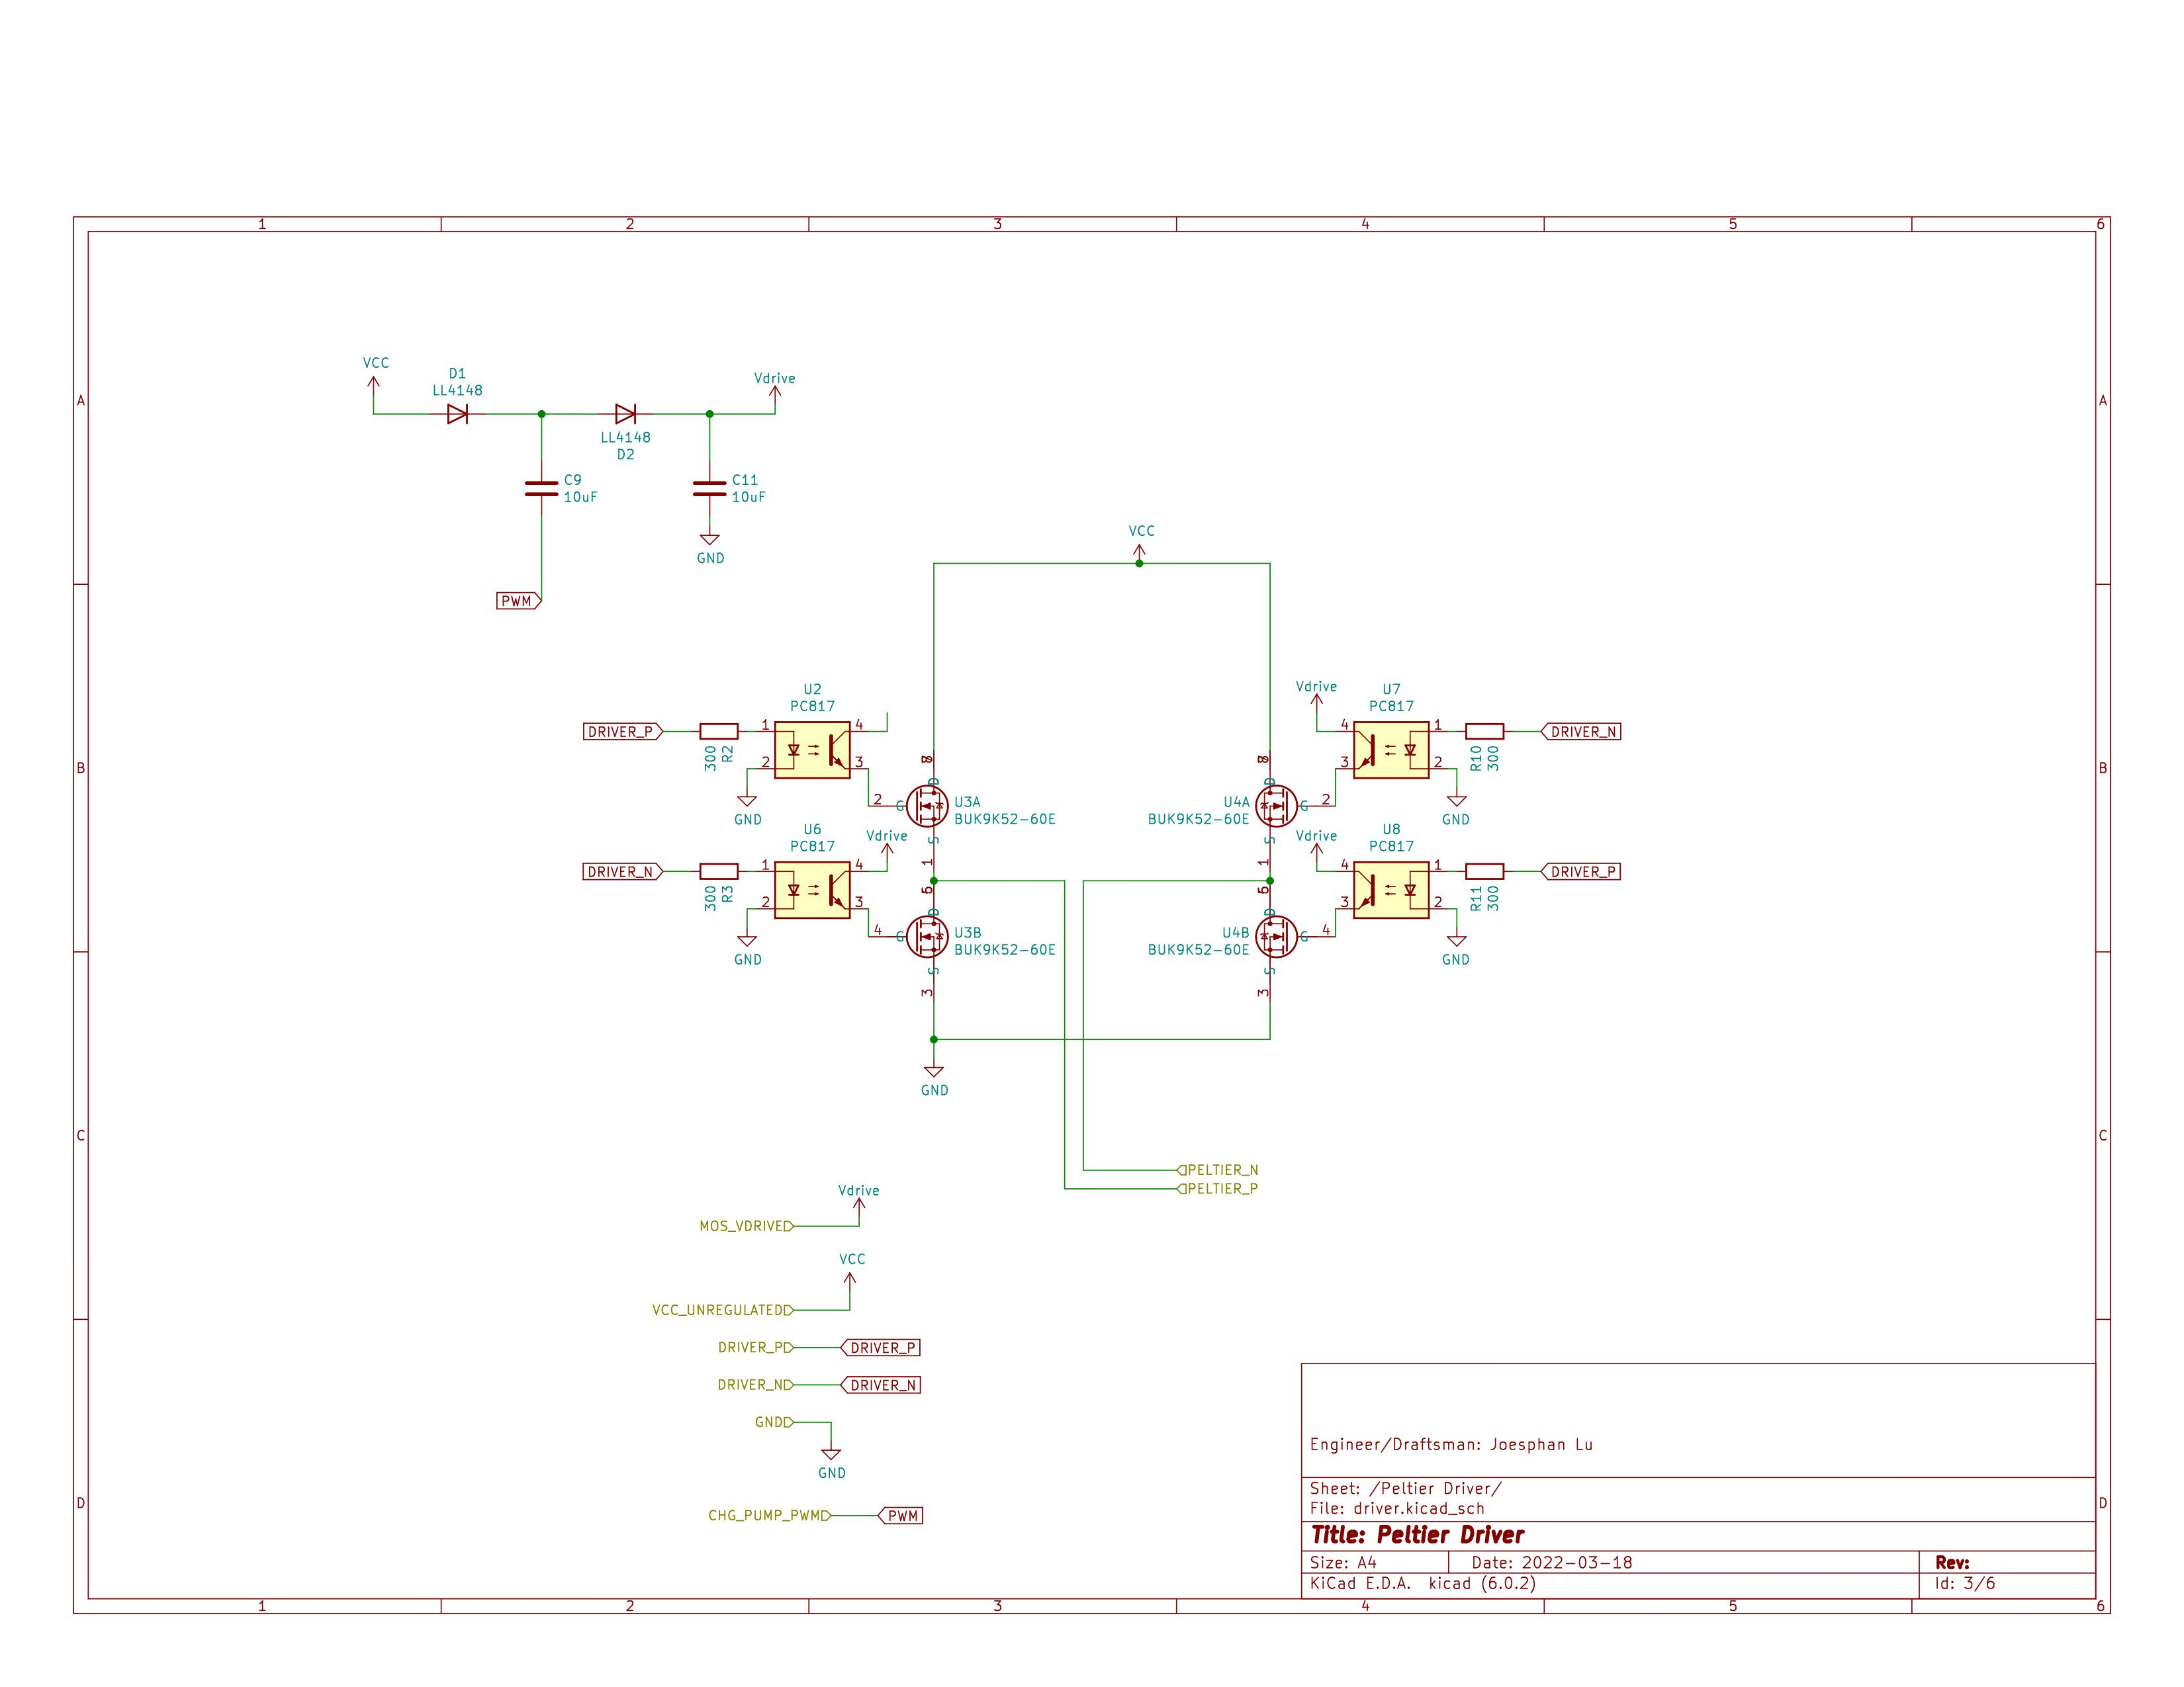

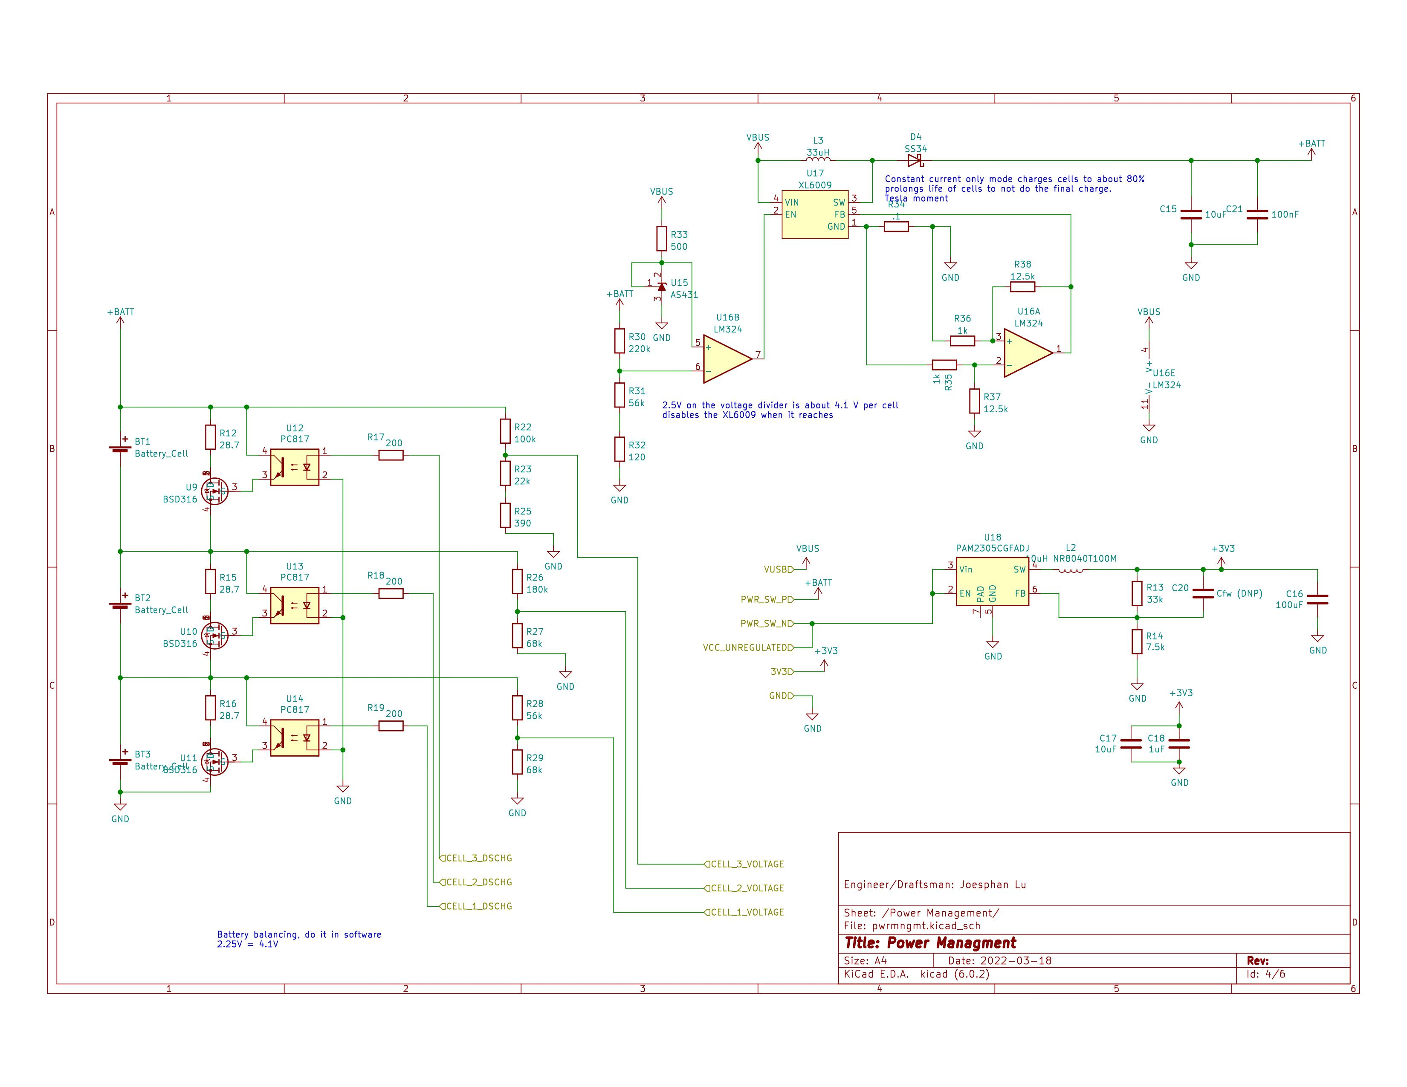

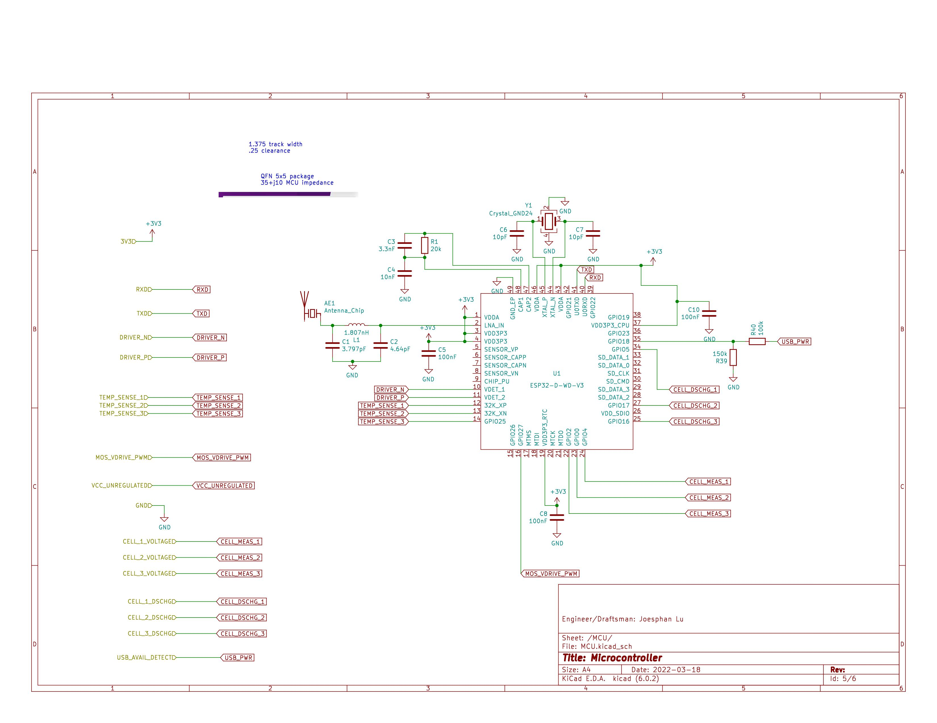

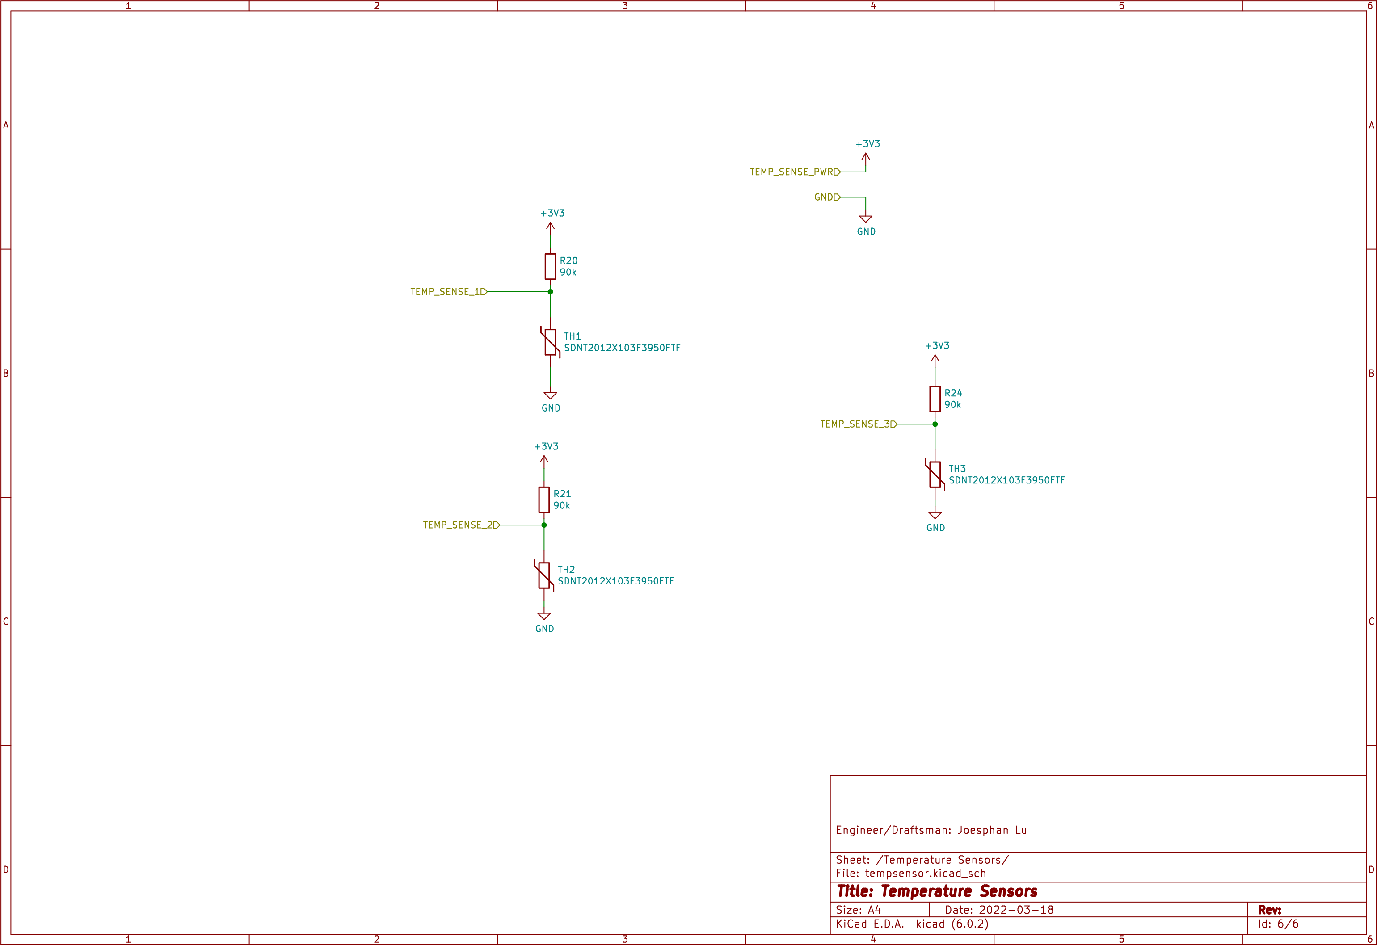

ARTWORK

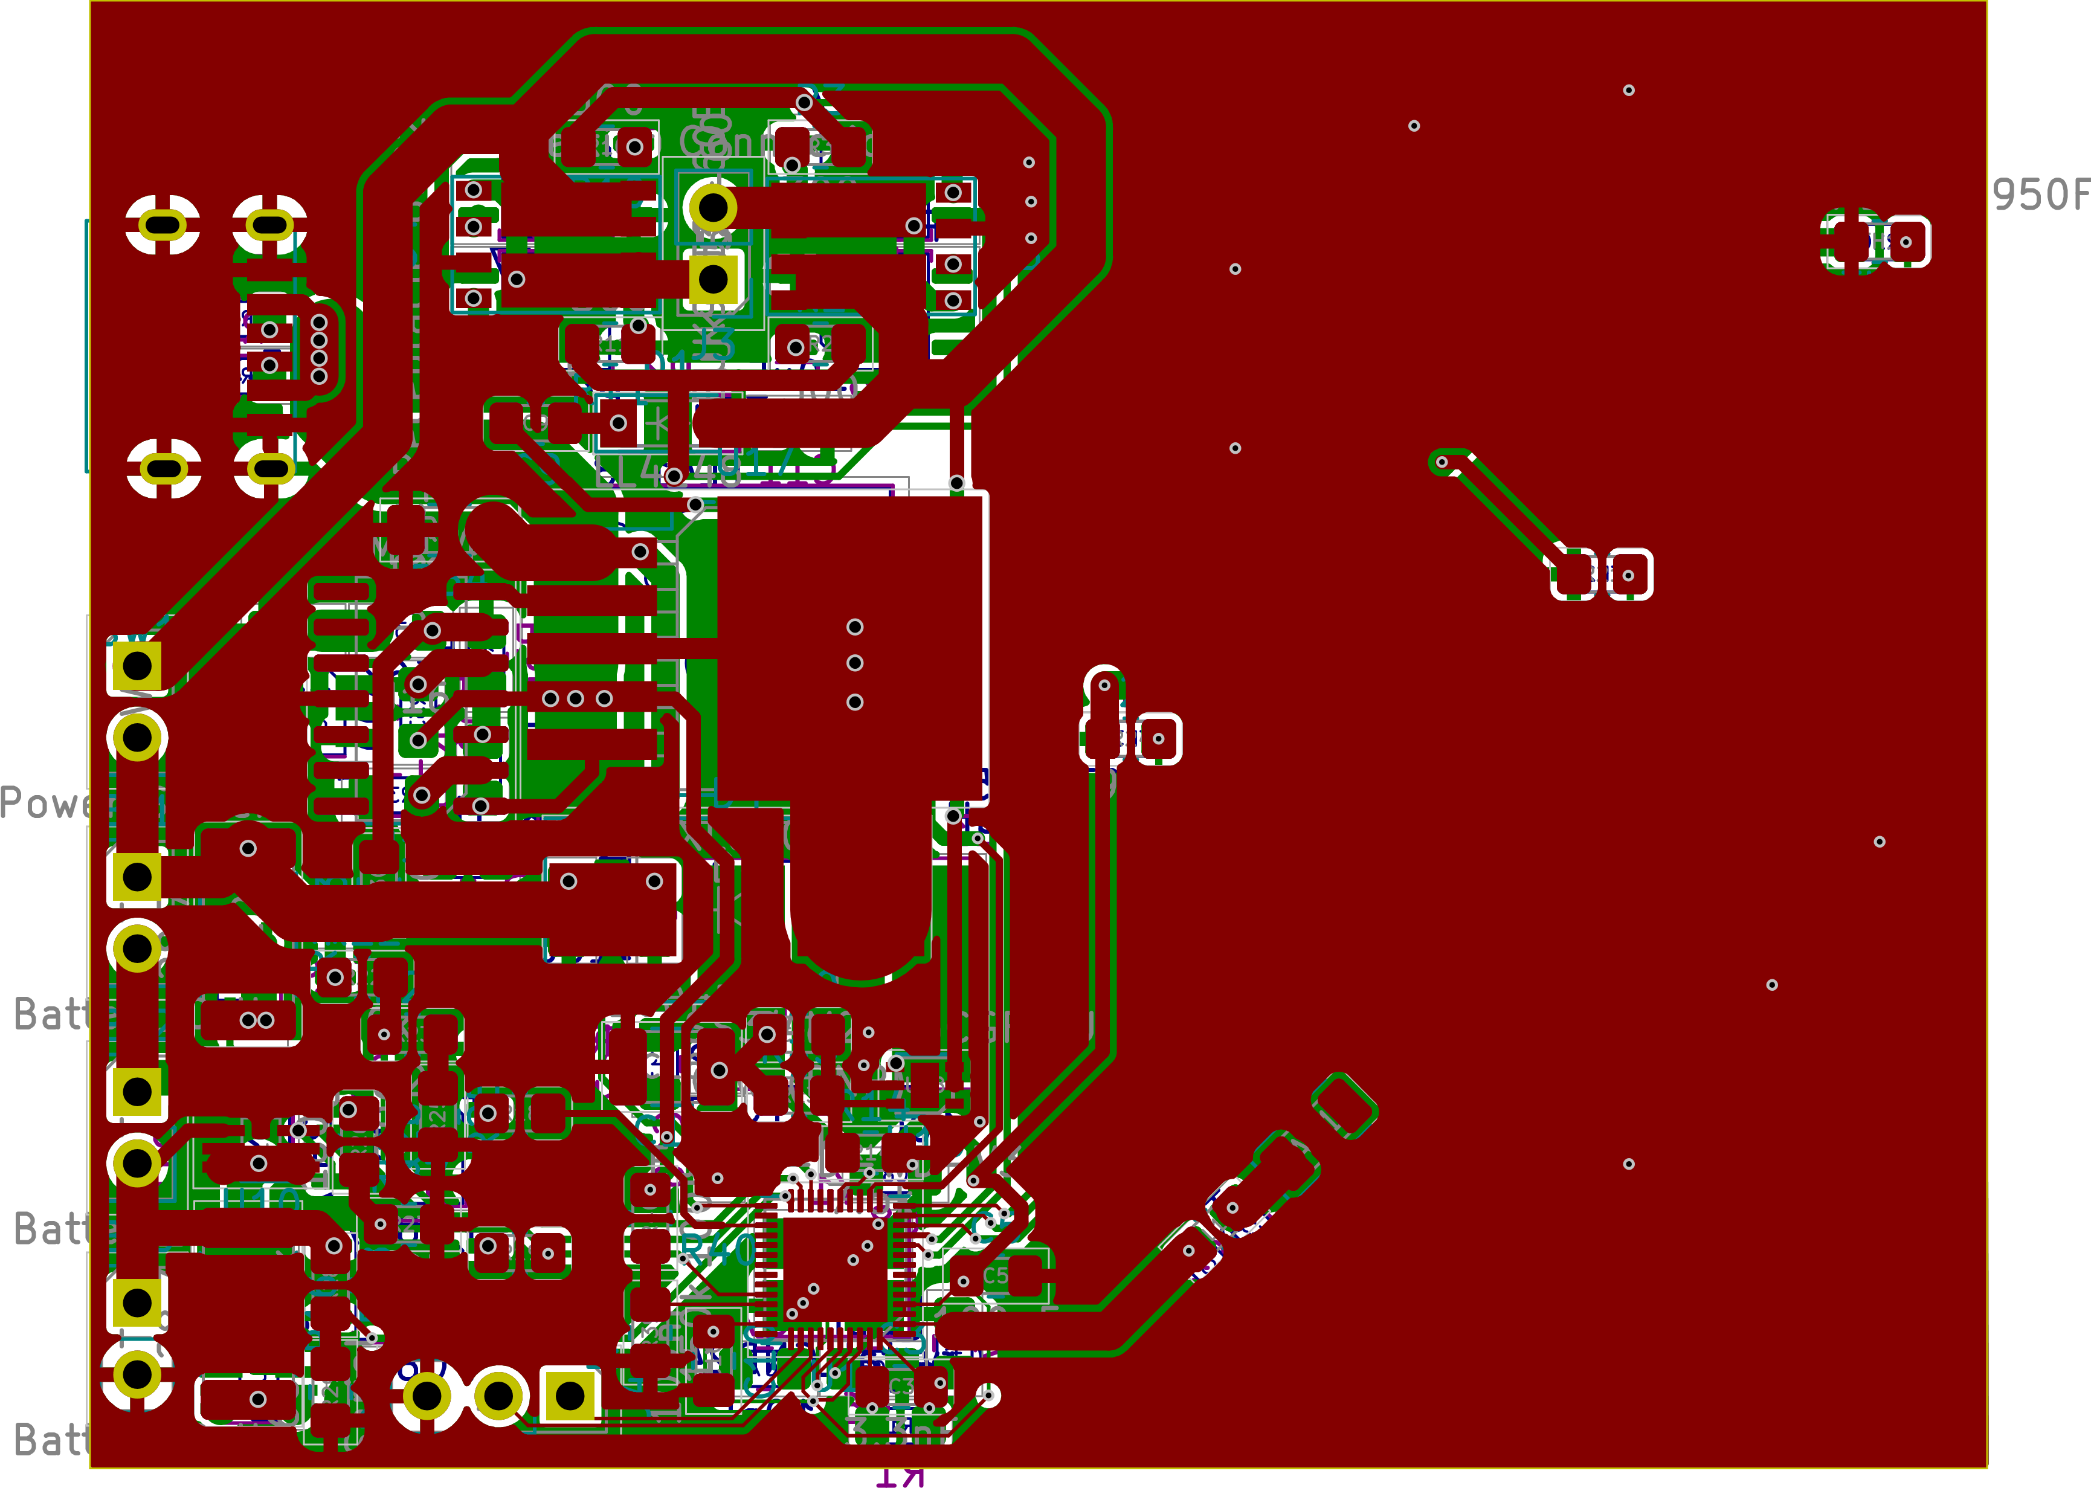Front:

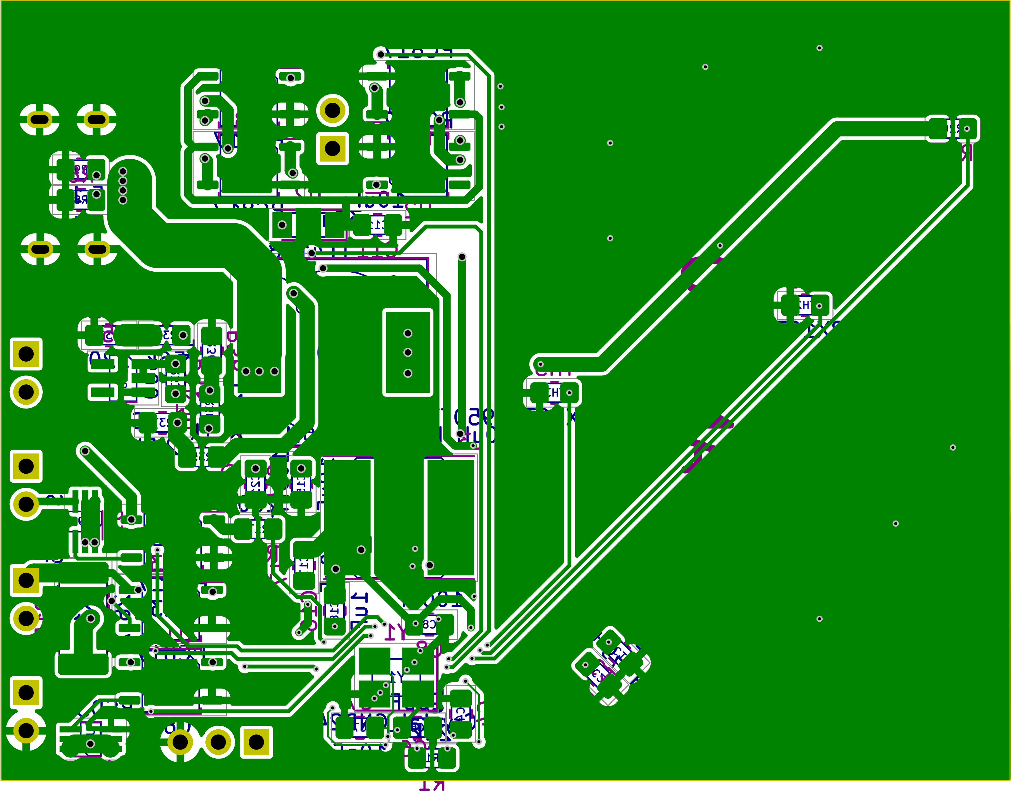Back:

A zoomable version kicad 6.0 is available at <https://github.com/joesphan/InsulinCooler/tree/main/schematic>

BILL OF MATERIALS

|  |  |  |  |  |
| --- | --- | --- | --- | --- |
| Qty | Reference(s) | Component | Footprint | Comments |
| 1 | AE1 | 2108838-1 | RF_Antenna:Johanson_2450AT18x100 |  |
| 3 | BT1, BT2, BT3 | Generic 18650 Battery | 2.54mm header pads, wires | Tack-weld onto battery terminals |
| 1 | C1 | 3.797pF | 0805 | generic |
| 1 | C2 | 4.64pF | 0805 | generic |
| 1 | C3 | 3.3nF | 0805 | generic |
| 1 | C4 | 10nF | 0805 | generic |
| 4 | C5, C8, C10, C21 | 100nF | 0805 | generic |
| 2 | C6, C7 | 10pF | 0805 | generic |
| 4 | C9, C11, C15, C17 | 10uF | 0805 | generic |
| 1 | C16 | 100uF | 1210 | CL32A107MQVNNNE or equivalent |
| 1 | C18 | 1uF | 0805 | generic |
| 1 | C20 | Cfw (DNP) | 0805 | generic, use as needed |
| 2 | D1, D2 | LL4148 | MiniMELF |  |
| 1 | D4 | SS34 | SMC |  |
| 1 | J2 | USB4125-GF-A | Custom; 1KicadLib:USB4125-GF-A |  |
| 1 | J3 | Peltier Connection | 2.54mm header pads, wires | TEC1-12706 type peltier |
| 1 | L1 | 1.807nH | 0805 | generic |
| 1 | L2 | NR8040T100M | Taiyo-Yuden NR-80xx | 10uH |
| 1 | L3 | 104CDMCCDS-330MC | 12x12h4.5mm | 33uH |
| 1 | R1 | 20k | 0805 | generic |
| 4 | R2, R3, R10, R11 | 300 | 0805 | generic |
| 2 | R8, R9 | 5.1k | 0805 | generic |
| 3 | R12, R15, R16 | 28.7 MCR100JZHF28R7 | 2512 | 1W |
| 1 | R13 | 33k | 0805 | generic |
| 1 | R14 | 7.5k | 0805 | generic |
| 3 | R17, R18, R19 | 200 | 0805 | generic |
| 3 | R20, R21, R24 | 90k | 0805 | generic |
| 2 | R22, R40 | 100k | 0805 | generic |
| 1 | R23 | 22k | 0805 | generic |
| 1 | R25 | 390 | 0805 | generic |
| 1 | R26 | 180k | 0805 | generic |
| 2 | R27, R29 | 68k | 0805 | generic |
| 2 | R28, R31 | 56k | 0805 | generic |
| 1 | R30 | 220k | 0805 | generic |
| 1 | R32 | 120 | 0805 | generic |
| 1 | R33 | 500 | 0805 | generic |
| 1 | R34 | 0.1 KDV12FR100ET | 1206 | 0.5W |
| 2 | R35, R36 | 1k | 0805 | generic |
| 2 | R37, R38 | 12.5k | 0805 | generic |
| 1 | R39 | 150k | 0805 | generic |
| 1 | SW1 | Power Switch | 2.54mm header pads, wires | Connected via headers |
| 3 | TH1, TH2, TH3 | SDNT2012X103F3950FTF | 0805 |  |
| 1 | U1 | ESP32-D-WD-V3 | Qfn48, 5x5, EP |  |
| 7 | U2, U6, U7, U8, U12, U13, U14 | PC817 | Sop-4 |  |
| 2 | U3, U4 | BUK9K52-60E | LFPAK56D |  |
| 3 | U9, U10, U11 | BSD316 | SC70 |  |
| 1 | U15 | AS431 | SOT23 |  |
| 1 | U16 | LM324 | SOIC14 |  |
| 1 | U17 | XL6009 | TO263 |  |
| 1 | U18 | PAM2305CGFADJ | DFN-6 |  |
| 1 | Y1 | RH100-40.000-10-F-1010-TR | SeikoEpson_FA238-4Pin_3.2x2.5mm |  |

PART SELECTION MINI REPORT

This whole design revolved around avoiding through-hole parts. The main reason behind it is that through hole parts offer a much smaller overall product package. This has many benefits, as well as a few downsides.

Through using surface mount parts, there is less overall material to manufacture. PCB etchant is not great for the environment and is relatively more difficult to dispose of safely. Using high-density routing techniques, I was able to get the board size to a very minimal size. Semiconductors in their surface-mount package result in a smaller size, which means less die packaging materials to manufacture.

In a situation when soldering through hole parts, a lot of solder will be used. Surface mount parts require less solder and offer better solutions than traditional soldering. Surface mount parts allow using paste and stencil, which deposit a very precise adequate amount of solder on to the pads. Through baking instead of using the iron, it allows the heating of the solder to occur in a different room than the operator. This should be considerably safer than hand soldering.

ASSEMBLY AND TEST PROCEDURE

* Solder J2, R8, and R9
  + Using a variable load, and USB C adapter, verify the USB port is delivering 15W, 5V out of pin A4 on J2
* Solder SW1
  + Verify conductivity between switch terminals with a voltmeter
* Solder on BT1-BT3, R12, R15, R16, U9-U11, U12-U14, and R17-R19
  + Put a voltmeter across each shunt resistor, and run a voltage between the 200ohm resistor and ground to activate the optocoupler
  + Verify each cell is able to drain, with the voltmeter across the shunt.
* Solder on the U16, U17, L3, D4, R34-R38, R30-R33, U15, C15, and C21
  + Connect USB-C power
  + Measure the 18650 battery voltage to have a positive delta, to ensure the XL6009 is charging the batteries.
* Solder U18, R13, R14, C16-C18
  + Turn the power switch in to the on position and measure the 3V3 rail to have 3V3

FINAL STATUS

I have redesigned most of my theories, so I still need to prove them. Most of the proof-of-concept boards have arrived, I need to test them over spring break. The buck converter was too low-performance to work, so I had to change that to one with higher frequencies. The buck converter, mc34063, was only as efficient as a linear regulator (not efficient).

I also had the bootstrap theory all wrong, didn’t realize it couldn’t turn a high-side NMOST on for a long time. I replaced it with a charge-pump design. In the simulator it worked fine as well as my free-air soldering lab test. The MOSFETS turned on properly all the way.

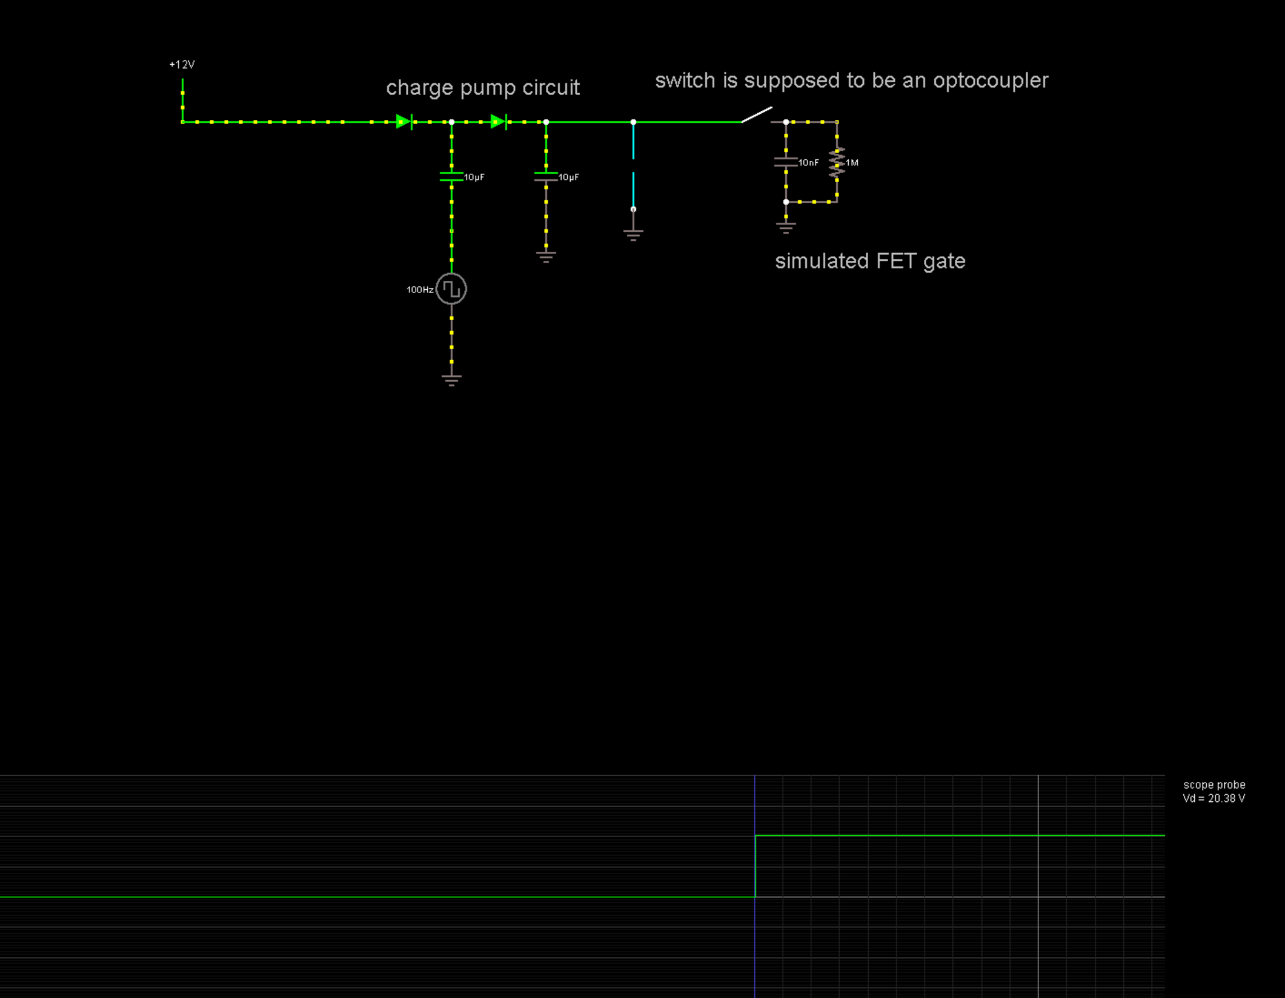

Another design big change I made was the battery charger. Since these peltiers used 14V, I hadn’t realized I didn’t design a 3S battery charging circuit, rather, only a 1S. The idea is to only charge the batteries up to 80%, for ease of design, and longevity. The balancing will be handled by the microcontroller.